Click here to enter your manuscript title. Use Title Case capitalization
*
*Corresponding Author. E-mail: correspondingauthor@email.com

ªFirst Institutional Affiliation, Address, City, Postal Code, Country
^{b}Second Institutional Affiliation, Address, City, Postal Code, Country
A B S T R A C T
Insert the abstract text here. The abstract should concisely state objectives, methods, core results and main conclusions, with no citations, abbreviations or reference markers.

Keywords: Insert 3–6 keywords separated by semicolons. Example: Keyword 1; Keyword 2; Keyword 3

Here introduces the paper, and put a nomenclature if necessary, in a box with the same font size as the rest of the paper. The paragraphs continue from here and are only separated by headings, subheadings, images and formulae. The section headings are arranged by numbers, bold and 9.5 pt. Here follows further instructions for authors.

  - Structure
All manuscripts must be submitted in editable MS Word (.docx) format only, formatted following this official AIJSTR template provided on the Instructions for Authors page. All figures, charts and tables shall be embedded inline within the text; separated image attachments are not required for initial submission.
Authors shall adopt universal standard fonts such as Times New Roman or Arial. Rare special fonts including Chinese, Japanese and Korean fonts may cause garbled text during copyediting and peer review. Before submission, please use the built-in Word spell checker to eliminate spelling and grammatical errors.
The fixed structural order of all manuscripts is mandatory: Article Title → All Author Names & Institutional Affiliations → Abstract → Keywords → Main Body (embedded figures & tables) → Acknowledgements (if applicable) → References → Appendices (if applicable).
Acknowledgements must be set as an independent section before References and shall not be placed on the title page or as title footnotes.
Bullet point lists are permitted in the main text. After finishing bullet lists, revert to the standard main body text style for subsequent paragraphs.
Do not manually modify preset page margins, column width, font sizes and paragraph styles in this template. All manuscripts adopt A4 paper (210 × 280 mm) double-column layout for direct printing. Page numbers will be uniformly added by editorial staff after acceptance; authors shall not add page numbers in submitted drafts. Leave one blank line to separate adjacent paragraphs. All standardized paragraph styles are preset in this template for unified layout.

Supplementary Academic Specifications
- Authorship Compliance
All listed authors must fully meet international standard authorship criteria: participating in research design, data collection, manuscript writing or critical revision, approving the full final manuscript, and taking accountability for all research content. Honorary authorship, gift authorship and ghost authorship are strictly forbidden and lead to direct desk rejection.
- Thesis-Adapted Manuscript Rules
Manuscripts rewritten from undergraduate, master’s or doctoral dissertations are acceptable. Corresponding authors must own complete copyright of the original thesis; if the university holds partial copyright, official written publication permission shall be provided upon editorial request. Simple excerpting and segmentation of thesis chapters without substantial rewriting are prohibited, and text overlap must conform to the limit in author guidelines. Concealing thesis source information counts as irregular submission.

  - Tables
All tables are numbered sequentially with Arabic numerals (Table 1, Table 2, Table 3…). Each table must carry an independent descriptive caption explaining its core content. Table captions are placed above the table body with left alignment.
Only horizontal dividing lines can be used inside tables: one line above column headers, one line below headers, and one full horizontal line at the bottom of the whole table. Vertical separating lines inside tables are forbidden.
All tables must be embedded inline within the corresponding text paragraphs and shall not be submitted as independent separate files. The following table is provided as a standardized example for authors’ reference.
Table 1 -Standard Table Format Example.
Column Header 1 | Numerical Column A | Numerical Column B
Sample Data 1 | 12.3 | 14.7
Sample Data 2 | 25.1 | 22.9
Sample Data 3 | 31.6 | 35.2
  - Construction of references
The References section shall be placed after Acknowledgements and before Appendices; starting a new page is not mandatory unless layout logic requires it. Authors must ensure every in-text citation corresponds to an entry in the reference list, and every listed reference is cited within the manuscript main text.
In-text citation adopts parenthetical author-year format: (Surname1, Surname2, Year) or (Surname, Year).
Standard reference formatting examples are displayed at the end of this template under the References section, which authors must strictly follow to unify citation font and layout. AIJSTR uniformly adopts APA reference style for all submissions.
  - Section headings
First-level section headings are left-aligned, bold, title case capitalized, and numbered consecutively starting from Introduction (1, 2, 3…).
Second-level subheadings adopt italic font, title case capitalized, numbered as 1.1, 1.2, 2.1…, left-aligned; wrapped text lines under subheadings shall be indented.
All headings must retain at least three full lines of text below before column break or page break to avoid blank column ends without content. Ensure no large blank space exists in the text area except for the last page of the whole manuscript.
  - General guidelines for the preparation of your text
Avoid automatic word hyphenation at line breaks. Scalar mathematical variables shall be marked in italic font; vectors, matrices and tensor symbols use bold font. All measured values and units must adopt international standard SI units.
All non-standard abbreviations, rare professional symbols and jargon must be fully defined upon their first appearance in text. Manuscripts with massive technical symbols may add an independent Nomenclature section at the front of the main body.

Supplementary Academic Rules
- Raw Research Data Storage Standard
All original experimental records, testing data, research code, survey materials and supplementary datasets supporting manuscript conclusions shall be preserved by authors for no less than 5 years after publication for audit and verification. The editorial board reserves the right to request original research data at any peer review or post-publication stage.
- Preprint Repository Policy
Authors are permitted to upload unreviewed manuscript drafts to recognized open preprint platforms before submitting to AIJSTR. After formal publication, authors shall update the preprint page with the official published DOI and complete citation information. Preprint posting will not be regarded as prior publication and will not cause automatic desk rejection.
- Similarity & Plagiarism Regulation
All submitted manuscripts will pass comprehensive similarity detection with professional academic detection tools. Manuscripts exceeding the journal’s similarity threshold will be returned for major revision before entering formal peer review. Self-citation of authors’ previously published works must be clearly marked and listed in references to avoid self-plagiarism risks.

  - File naming and delivery
The official manuscript file naming format is fixed as: AIJSTR_ManuscriptID_CorrespondingAuthorLastName.docx
At initial submission, authors only need to upload the editable .docx source file through our online submission portal. PDF versions are only required after formal manuscript acceptance for final typesetting and production.

Supplementary specification for artwork attachment filenames follows the unified syntax “aabbbbbb.ccc”:
- a = artwork type code
- b = official AIJSTR Manuscript ID
- c = standard file extension
- Type codes definition:
- gr = figure image
- pl = plate
- sc = scheme diagram
- fx = fixed graphic element
  - Footnotes
Footnotes shall be minimized as much as possible. If footnotes are necessary, mark relevant content in text with sequential lowercase superscript letters. Footnote text uses single-spaced layout with small 7pt font, placed at the bottom of the column where the marked content appears, separated from main text by a full-width horizontal dividing line. The preset footnote paragraph style is available within this template.
Do not manually adjust template page margins; improper margin modification may lead to footnote content being cut off during printing.

- Illustrations
All photographs, graphs, schematics, flowcharts and diagrams are uniformly defined as Figures, numbered sequentially with Arabic numerals (Fig. 1, Fig. 2, Fig. 3…). Every figure must carry an independent descriptive caption.
Line artwork must be high-definition electronic vector graphics or high-quality scanned copies; blurry low-resolution screenshots are not acceptable and will be returned for reupload. All figures must be embedded inline within the manuscript text instead of being submitted as separate image files. All labels, legends and symbols inside figures must be clearly legible and explained either in figure captions or within the graphic itself.
Figures should be placed at the top or bottom of columns, as close as possible to the first textual citation of this figure. Two related small figures may be arranged side by side to save layout space.
Figure captions are typed below each illustration with 8pt font and left alignment; single-line captions shorter than column width can be centered. No text shall wrap alongside figures in main text paragraphs.

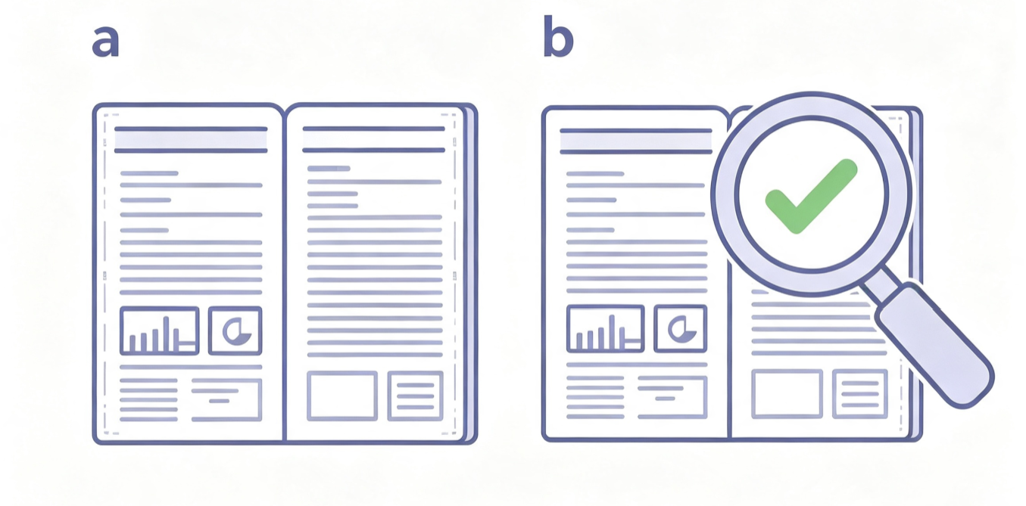
Fig. 1 – (a) First sample graph; (b) Second sample schematic diagram

- Equations
All mathematical formulas and equations shall be edited via Math Type or the built-in Word Equation Editor. Equations that are cited within the main text are numbered sequentially with Arabic numerals enclosed in parentheses on the right margin of the text column. One blank line shall be reserved both above and below each equation to separate formulas from ordinary text content.
4. Copyright & Publishing License Rules
All corresponding authors retain full, perpetual, worldwide copyright of their original submitted manuscripts. AIJSTR will never request copyright transfer, full assignment or exclusive licensing agreements at any stage of submission, peer review or formal online publication.
After receiving the official written acceptance letter, all authors voluntarily grant AIJSTR a perpetual, worldwide, royalty-free, non-exclusive, sublicensable publishing license to carry out the following authorized publishing activities:
- Digitally publish, permanently archive and store full-text articles on the official journal website and affiliated open academic repositories;
- Transmit manuscript metadata, abstracts and full text to global academic indexing databases, retrieval engines and library resource platforms for permanent open public access;
- Conduct standardized copyediting, language polishing, unified typesetting and minor layout adjustment to comply with AIJSTR uniform publication specifications;
- Permanently display published full articles online for free reading, downloading, citation and non-commercial academic communication under CC BY 4.0 license terms.
Authors retain complete independent reuse rights of their research content after publication, including translation, reorganization, derivative research, conference presentation, classroom teaching and institutional repository archiving, on the premise of complete standardized citation of the original AIJSTR published article.
If the manuscript contains third-party copyrighted images, tables, charts, long quoted text or proprietary datasets, the corresponding author must obtain full written reproduction authorization from original copyright holders before submission. All permission documents shall be properly preserved and submitted to the editorial team for inspection upon request.
Acknowledgements
The heading of Acknowledgements and References shall be left-aligned, bold, title case capitalized without numerical numbering. Normal paragraph format applies to all text under this heading.
- An example appendix
Authors with supplementary content that cannot be integrated into the main body shall set an independent Appendix section placed before References. Multiple appendixes are labeled sequentially as Appendix A, Appendix B, Appendix C. Subheadings inside each appendix follow the same numbering logic as main text (A.1, A.1.1, A.2…).
  - Example of a sub-heading within an appendix
There is also the option to include a subheading within the Appendix if you wish.

Research Ethics & Conflict of Interest

- Human and Animal Experiment Ethics
Studies involving human research participants must attach formal institutional review board (IRB) ethics approval documents and complete informed consent records of all subjects. Research using laboratory animals shall comply with international animal welfare standards and provide official animal experiment ethics certification. Manuscripts without valid ethics documents will receive direct desk rejection.
- Full Conflict of Interest Disclosure
All potential financial benefits, institutional cooperation, consulting income, patent rights, stock ownership, research project grants and commercial partnerships related to this research must be fully and truthfully disclosed in the cover letter and manuscript text. Concealed undisclosed conflicts of interest will cause delayed peer review or post-publication correction notice.
- Ban on Dual Submission & Duplicate Publication
This manuscript and all substantially similar versions shall not be simultaneously submitted or under peer review of any other journals, conference proceedings or publishing institutions. Once dual submission behavior is verified, the manuscript will be rejected, and the corresponding author will receive official submission restriction notification from editorial office.
References
All reference entries below follow AIJSTR unified APA citation format for authors’ reference.
Van der Geer, J., Hanraads, J. A. J., & Lupton, R. A. (2000). The art of writing a scientific article.Journal of Science Communication, 163, 51–59.
Strunk, W., Jr., & White, E. B. (1979).The elements of style (3rd ed.). New York: MacMillan.
Mettam, G. R., & Adams, L. B. (1999).How to prepare an electronic version of your article. In B. S. Jones & R. Z. Smith (Eds.), Introduction to the electronic age (pp. 281–304). New York: E-Publishing Inc.
Fachinger, J., den Exter, M., Grambow, B., Holgerson, S., Landesmann, C., Titov, M., et al. (2004).Behavior of spent HTR fuel elements in aquatic phases of repository host rock formations, 2nd International Topical Meeting on High Temperature Reactor Technology. Beijing, China, paper #B08.
Fachinger, J. (2006). Behavior of HTR fuel elements in aquatic phases of repository host rock formations.Nuclear Engineering & Design,236, 54.

Final Author Submission Checklist

Before uploading your manuscript via AIJSTR online submission portal, please complete all items below:
- The manuscript fully complies with all format rules specified in this official template;
- All ethics approval, subject informed consent and third-party copyright permission documents are prepared for editorial inspection;
- Complete conflict of interest statement and thesis source declaration (if applicable) are written within the cover letter;
- All co-authors have fully read, approved the manuscript and agreed to this submission;
- Manuscript similarity detection report is available upon editorial request;
- Manuscript saved as editable .docx file with official standardized filename.

Post-Acceptance Procedures

- Fill, sign and scan the Non-Exclusive Publishing License Agreement as a PDF attachment and send to editor@aijstr.com;
- Revise the typesetting proof according to copyeditor feedback within the specified time limit;
- Complete official APC payment to activate formal online publication.

Official Editorial Contact: editor@aijstr.com
Official Journal Website: aijstr.com

Footnote text.

